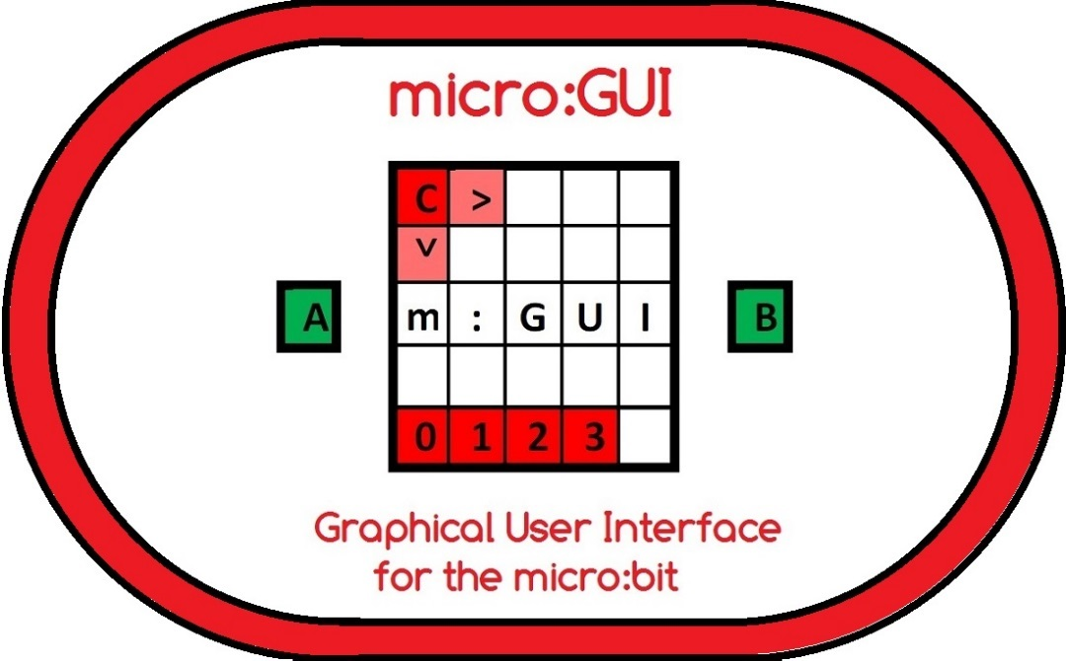
by Innovations in Education
Version 1.0 – 20th January 2018

micro:GUI Overview
This specification defines a 'Graphical User Interface' or 'GUI' for the BBC micro:bit which acts like a simplified version of the GUI used on most Smart Phones. It uses Buttons A & B on the micro:bit as 'User Input' and the 5x5 LED Matrix on the micro:bit as the 'Display'. One LED acts as the 'Cursor' and the LEDs along the bottom row act as the 'Apps' thus creating a 'micro:GUI'. The specification shows how it is possible to create an intuitive micro:GUI within the constraints of the limited controls and display resolution available on the micro:bit. The micro:GUI could for instance allow multiple programs, known as 'micro:Apps', to reside in a single Hex file with the micro:App 'launched' using the micro:GUI.
Furthermore, the fact that the micro:GUI can function with limited controls and limited display resolution lends itself to being adapted to use other forms of 'User Input' and other forms of 'Display'. For example, the 'User Input' could be by Tilt/Shake Control, Headphone Button Control, Joystick Control or Voice Control and the 'Display' could 'Auto Rotate' or be an 'Audio Display'.
The primary purpose of the micro:GUI is for education. A 'Basic' micro:GUI implementation could be coded in Block. It could be incorporated into computing lessons to help students understand the concepts of a Graphical User Interface and give students the opportunity to code their own micro:GUI. In doing so students would learn how to:-
- write code to monitor inputs from the micro:GUI Navigation Controls
- move a 'micro:Cursor' in response to the micro:GUI Navigation Controls
- write code for one or more 'micro:App' programs
- 'install' one or more micro:App programs on the micro:GUI
- display a 'micro:Icon' whenever the micro:Cursor is on a micro:App LED
- 'launch' their micro:App on a micro:bit using their micro:GUI

micro:GUI specification Version 1.0 covers 'Basic' micro:GUI functionality. Future versions will add 'Advanced' micro:GUI features, some of which may require coding in JavaScript or Python.
micro:GUI Display Overview
The micro:GUI display has 4 elements:-
- 'micro:Cursor' LED
- 'micro:App' LEDs along the Bottom Row
- 'micro:Icons' in the Centre of the Display
- 'micro:Option' LEDs along the Top Row ('Advanced')
micro:Cursor |  |  |  |  |  | micro:Apps |  |  |  |  |  | micro:Icons |  |  |  |  |  | micro:Options
C |  |  |  |  |  |  |  |  |  |  |  |  |  |  |  |  |  |  | T | H | J
 |  |  |  |  |  | 0 | 1 | 2 | 3

The micro:App LEDs along the Bottom Row can be seen as the equivalent of the fixed App Icons along the bottom of most Smart Phone displays.
The micro:Option LEDs along the Top Row can be seen as the equivalent of the menu items along the top of most desktop PC programs.

micro:GUI Display LEDs
Each Display LED is set to one of 5 states:-
LED Off [ ]
LED On [ ]
LED Half On [ ] (Advanced)
LED Slow Flash [C] (approx 1 second ‘on’/1 second ‘off’) (Advanced)
LED Fast Flash [F] (approx 0.5 seconds ‘on’/0.5 seconds ‘off’) (Advanced)

PushButton Navigation Controls
micro:bit PushButtons A, B and Reset are used to navigate the micro:GUI.
Used with a ‘Short Press’ gives 4 'Basic' micro:GUI Navigation Controls:-
Button ‘A’ – Short Press <A>
Button ‘B’ – Short Press <B>
Button ‘A+B’ – Short Press <A+B>
Reset Button <Reset>

'Basic' micro:GUI - Navigation Controls
Button 'A' is used to move the ‘micro:Cursor’ in the Y-axis ↓
Button 'B' is used to move the ‘micro:Cursor’ in the X-axis →
A Short Button 'A' press <A> is used to move the micro:Cursor Down ↓ one LED to (0,1) then to (0,2),(0,3),(0,4) and back to (0,0).
A Short Button 'B' press <B> is used to move the micro:Cursor Right → one LED to (1,0) then to (2,0),(3,0),(4,0) and back to (0,0).
A Short Button 'A+B' press <A+B> is used to 'Launch' a micro:App.
A Reset Button press <Reset> is used at any time to Return to the Home Screen and Close any micro:Apps.

'Basic' micro:GUI - Home Screen
At Power Up, Reset or on 'Return to Home Screen' the micro:bit displays the 'Home Screen' with available micro:App LEDs along the bottom of the display and the 'micro:Cursor' [C] in the top-left of the display - LED (0,0). For a 'Basic' micro:GUI implementation the 'micro:Cursor' [C] would not 'Slow Flash'. It would just be 'On' [ ]

C
1 | 2 | 3 | 4

At any time a Reset Button press <Reset> returns to this Home Screen.

'Basic' micro:GUI - Cursor Navigation
At Power Up, Reset or 'Return to Home Screen' the micro:Cursor [C] appears in the Top Left LED (0,0) position.

C

Button 'B' – Short Press <B> moves the 'micro:Cursor' one LED Right → in the X-axis to LED (1,0).
C

A subsequent Button 'A' – Short Press <A> moves the 'micro:Cursor' one LED Down ↓ in the Y-axis to LED (1,1).
C

The micro:Cursor [C] 'Wraps Round' from Right-to-Left and Bottom-to-Top of the Display, hence...
When the micro:Cursor [C] is moved to an LED in the Right Column i.e. LED (4,Y) a Button 'B' – Short Press <B> moves the micro:Cursor back to the Left Column i.e. LED (0,Y) like this:-
 |  |  | C | > |  |  |  |  |  |  | C | > |  |  |  |  |  |  | C | > |  | C | >
 |  |  |  |  |  | B |  |  |  |  |  |  | B |  |  |  |  |  |  | B |  |  |  |  |  |  | B

When the micro:Cursor [C] is moved to an LED on the Bottom Row i.e. LED (X,4) a Button 'A' – Short Press <A> moves the micro:Cursor back to the Top Row i.e. LED (X,0) like this:-
 |  |  |  |  |  |  |  |  |  |  |  |  |  |  |  |  |  |  |  |  |  | C
 |  |  |  |  |  |  |  |  |  |  |  |  |  |  |  |  |  |  |  |  |  | ˅
A | C |  |  |  |  |  | A |  |  |  |  |  |  | A |  |  |  |  |  |  | A
 | ˅ |  |  |  |  |  |  | C
 |  |  |  |  |  |  |  | ˅ |  |  |  |  |  |  | C
 |  |  |  |  |  |  |  |  |  |  |  |  |  |  | ˅
Navigated in this way the micro:Cursor [C] can be moved to any location on the 5x5 LED matrix with a maximum of 8 Button Presses.
'Basic' micro:GUI - micro:App LEDs
micro:Apps are indicated by the LEDs along the bottom of the display. So, for instance, if there were 4 micro:Apps 'installed', the Home Screen would have LEDs (0,4),(1,4),(2,4),(3,4) 'On' as shown below.
C
0 | 1 | 2 | 3

If micro:Apps are numbered in any documentation, the numbering should be from 0 upwards to match the LED Column Number relating to the location of that micro:App’s LED on the display.

'Basic' micro:GUI - micro:Icons
Moving the micro:Cursor [C] onto one of the micro:App LEDs brings up the associated 'micro:App Icon' (or 'micro:Icon') on the display. micro:Icons could be things like:-
Image.HEART
Image.DIAMOND
Image.HAPPY
...etc from the MicroPython images library, or any other user configured Icon. As an example, if micro:App(0,4) uses the SMALL_DIAMOND micro:Icon, when the micro:Cursor [C] is moved to LED(0,4) the SMALL_DIAMOND would appear on the display like this:-
C

Note that to help the micro:Icon stand out and to simplify the coding, the micro:App LEDs and the micro:Cursor [C] LED can be ‘Off’ when a micro:Icon is displayed.

'Basic' micro:GUI - Launching a micro:App
When the micro:Cursor [C] is on a micro:App LED and the micro:Icon is displayed, a Short Button 'A+B' press <A+B> 'launches' the micro:App.
C

Once a micro:App is running the entire display is available for use by the micro:App.

'Basic' micro:GUI - Closing a micro:App
A Reset Button press <Reset> is used to close the micro:App and return to the Home Screen.

---------------------------------------------------------------------------------------------------------

Open Specification
This as an 'Open Specification', freely available for anyone to use, distribute and/or modify under a 'Creative Commons' licensing arrangement. Innovations in Education however retains copyright for the specification and requests that if used by a commercial organisation, the organisation acknowledges the specification’s contribution to their micro:GUI implementation.

Contact
Innovations in Education can be contacted via the Web Site www.zbit-connect.co.uk
or via Twitter @ZbitConnect

Change History
V1.0 – First 'Published' Version specifying 'Basic' micro:GUI functionality - 20th Jan 2018

